Foraging assay set up and protocol

**Bacteria collection**

1. Obtain fresh blueberry samples from farm lands in Alachua county (Straughn farms).
2. Obtain both ripened and ripening berries.
3. Place 3 ripened berries into a falcon tube with 30 ml of distilled water. Close the tube then shake vigorously for a few seconds. (repeat process for 3 unripen berries).
4. Pipet 150 µl of the DI water blueberry mix and place onto a media culture plate LB/MRS/TSA.
5. Use the bead method to spread the sample on the plate.
6. Incubate the plates for 48h at 37℃.
7. Isolate unique colonies and inoculate in the liquid media they were plated on.
8. Incubate for 24h in a shaking incubator at 32℃.
9. Prepare glycerol stock for future use.

**Bacteria Culture set up**

1. Obtain desired bacteria for testing either from glycerol stock or from an isolate on culture plate.
2. Inoculate into a liquid medium at 3ml (LB/MRS/TSB, dependent upon which one it was isolated on originally).
3. Incubate the sample in the shaking incubator for a 24-hour period at 32℃.
4. Pipette 1.5 ml of the liquid culture into an Eppendorf tube then centrifuge at 8,000 rpm for 10 minutes.
5. Pipette off supernatant, add 1.5 ml of 1% saline water then homogenize the sample.
6. In the A# Traps add 3ml bacteria in saline solution
7. Then insert 3 ml of blueberry juice into the A# traps.

**Fungal growth**

1. For fungi incubate samples at 37℃ samples on a MEA culture plate for 24-48 hours.
2. Once a large colony sized is reached transfer using either a sterile wooden inoculating stick or a sterile pestle into the A# trap with 3ml of Blueberry juice.

**Arena Construction**

1. Obtain a weighing boat (W 4.2 cm x L 5.6 cm) 1 weighing boat needed for every trap.
2. Roll two cotton balls into a conical shape then moisten them with water place cotton balls into the weighing boat.
3. Place the weighing boat in the foraging arena.
4. Insert 3ml of blueberry juice and 3ml of 1%saline water into the B# trap this will be the control.
5. Place experiment sample (blueberry juice 3 ml and microbial inoculum 3ml) into the A# traps (see Pictures below) then seal the arenas.
6. Once both A and B Traps have been sealed, place onto the tray of the arena then put on the lid. Once arena is assembled use masking tape to seal all the edges and creases around the arena to prevent flies from escaping (See “Completed Arena” below).
7. Once the arena is sealed, open the Eppendorf tube at the top and place inside a small funnel into its hole.
8. Gas fly colony with CO2 for a few seconds (Until none are flying around), then drop them into the funnel for them to enter the arena.
9. Ensure arena has around 15-20 flies.
10. Once the flies are in the arena remove the funnel and seal the Eppendorf.
11. Note if the flies get stuck in the funnel use a small amount of DI water to push them down the funnel or use an air pump.
12. Once arenas are set, allow to sit for a 3-day period to allow flies to “normalize” and properly choose a Trap.
13. On the 3rd day, record all data on how many fly’s chose either A or B and as well how many did not enter a Trap.

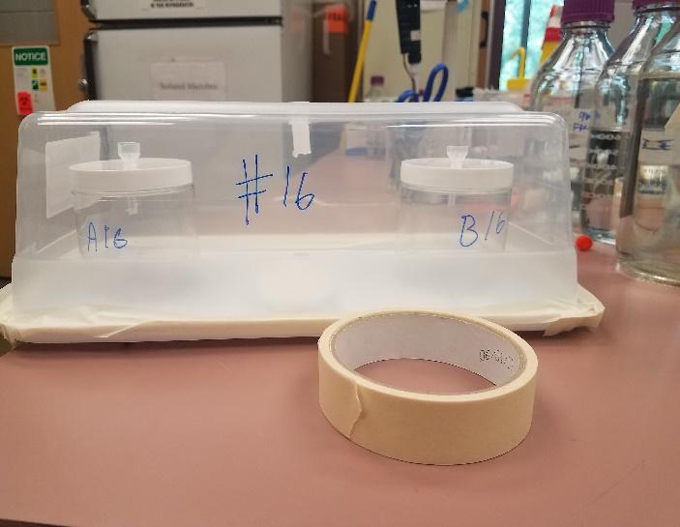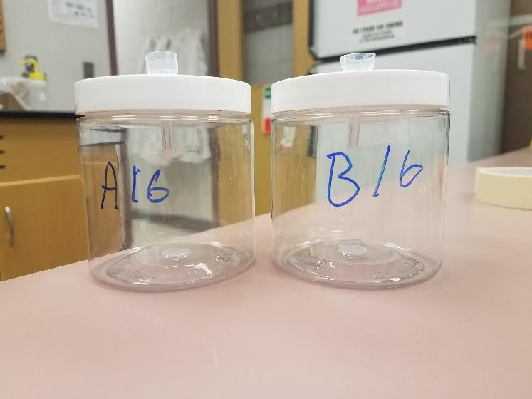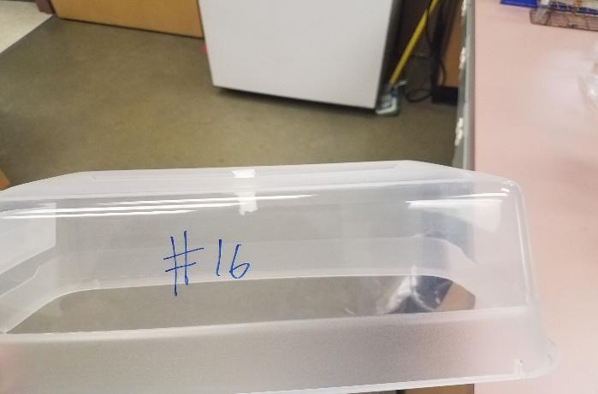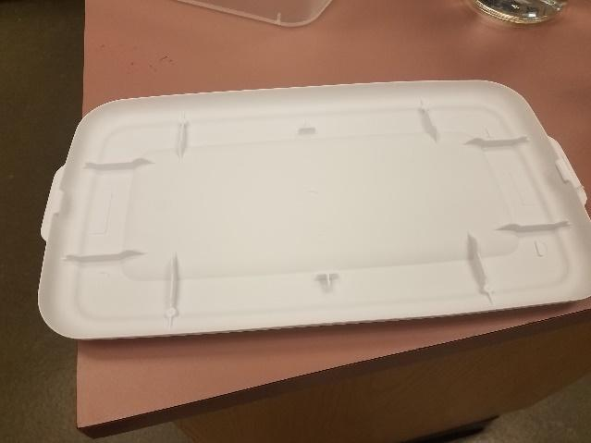

Completed Arena

Traps

Lid

Tray